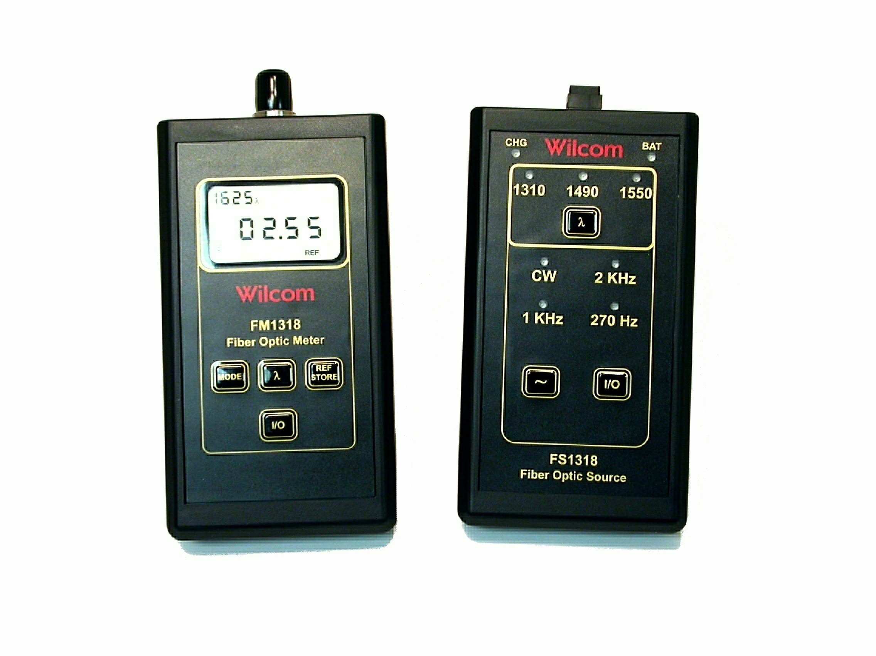

Product Release

FOR IMMEDIATE RELEASE: January 21, 2005

For more information, please contact: John W. Adams
800-222-1898 (USA only) * 603-524-2622
Fax 603-524-3735
email jwadams@wilcominc.com

Wilcom Introduces new Optical Power Meter & Fiber Light Source for FTTx applications

Laconia, NH Wilcom, a world leader in Optical Fiber Identifiers, continues its role in the hand-held fiber optic test equipment arena by introducing two new products, the Model
FS-1318 Tri-Wavelength Fiber Source, and the Model FM-1318 Optical Power Meter for FTTx applications. Both units are in a new case equipped with a bale which offers more flexible mounting positions.

The Model FS-1318 Tri-wavelength Fiber Source is a single port device employing an SC/UPC connector port and provides 1310nm, 1490nm & 1550nm wavelengths allowing this unit to test passive optical networks (PONs) at the three main wavelengths recommended by the ITU-T (G.983.3) for use in fiber-to-the-home (FTTH) and fiber-to-the-premise (FTTP) networks. This unit also provides CW, 270Hz, 1kHz and 2kHz modulation.

The Model FM-1318 Optical Power Meter is calibrated at 850nm, 1300nm, 1310nm, 1490nm, 1550nm & 1625nm wavelengths making it ideal for testing passive optical networks (PONs) at the three main wavelengths recommended by the ITU-T (G.983.3) for use in fiber-to-the-home (FTTH) and fiber-to-the-premise (FTTP) networks. With the additional wavelengths, it is also ideal for general purpose testing of multimode and singlemode fiber systems. This model also detects and displays 2-kHz, and easily stores a reference measurement making “zeroing” out the meter a simple step saving valuable time.

For further information, please contact sales@wilcominc.com, or view our web site www.wilcominc.com , or contact your local Wilcom representative.

